**CVHEC Annual Higher Education Summit**

***Navigating Higher Education in a New Era - The Central Valley Way***

May 9, 2025

9:00 a.m. – 3:00 p.m.

DoubleTree by Hilton Hotel Fresno Convention Center

2233 Cesar Chavez Blvd, Fresno, CA 93721

**Parking Instructions**

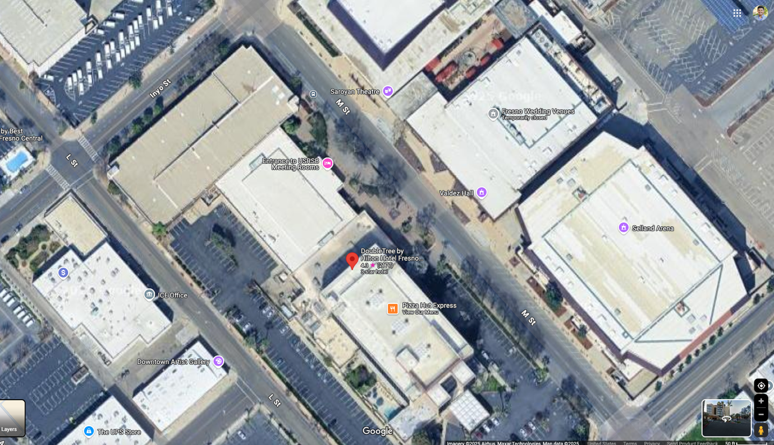



* Please park at the 728 L St Garage located at 728 L St, Fresno, CA 93721(Marked by the Red Star)
  + Tell them you are there for the CVHEC Higher Education Summit
* The event will take place in the Double Tree Hotel Conference Center and can be accessed through the side entrance (marked in light blue)